Name: __________________________________________________________________

Teacher: ________________________________________________________________

How Can Champions Help Us on Our Path?

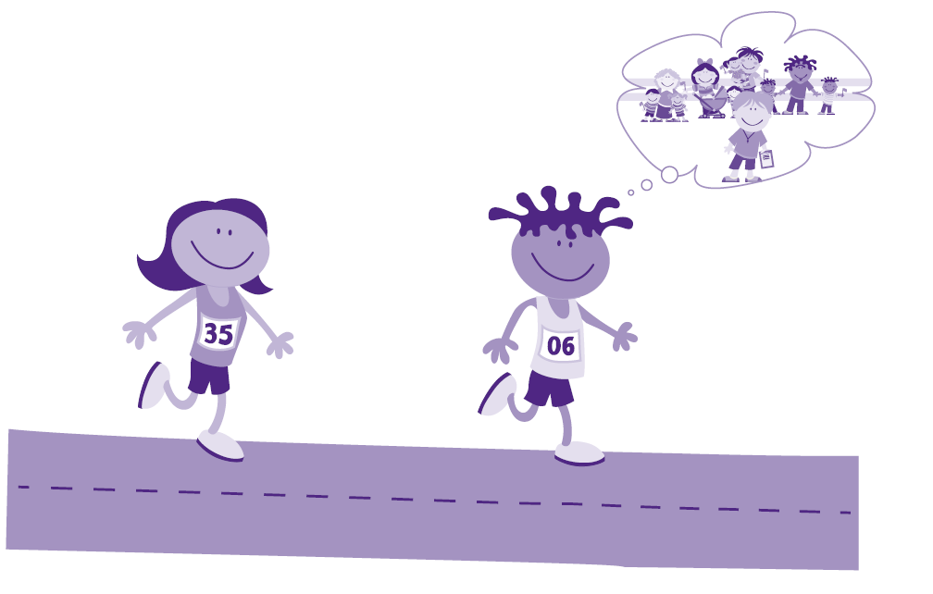
Who do you think will finish first—the runner who trains alone or the runner who trains with a coach and has a team to cheer him on? Why?
______________________________________________________________________________________________________________________________

How can champions help us on our path?
______________________________________________________________________________________________________________________________

